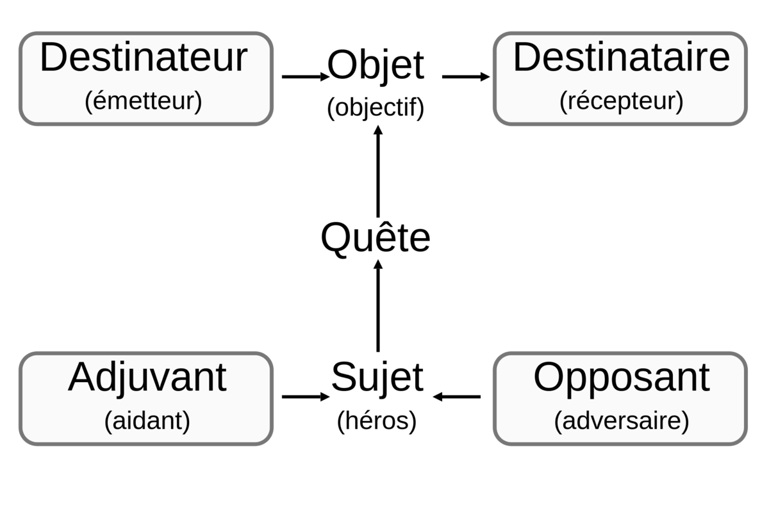

[source](https://upload.wikimedia.org/wikipedia/commons/thumb/e/e6/Sch%c3%a9ma_actantiel.svg/2000px-Sch%c3%a9ma_actantiel.svg.png)